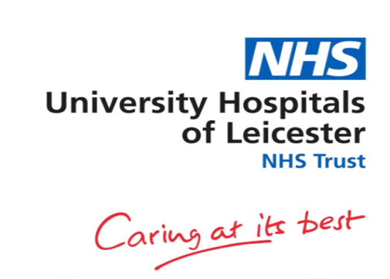
Equality Analysis – Crib Sheet Guidance

The Equality Analysis Crib Sheet is a useful tool to help collect equality data/information. This crib sheet will assist you in identifying the key equality issues and provides you with the opportunity to ensure we meet the requirements of the Equality Delivery System 3 (EDS3), Public Sector Equality Duty (PSED) and the Equality Act 2010.

The CQC will be requesting evidence of good equality practice and how we plan to use information to improve the service we provide to patients (their families/carers), staff and our diverse communities.

Step-by-Step Guide:

- Capture the information relating to the event/meeting, including the date and the venue.
- Explain why the event is taking place and its objectives.
- Capture the attendees/audience for example patient groups, strategic partners, community groups and staff.
- Consider the attendees/audience in relation to their protected characteristic. For example, if you’re working with a specific community group. Please be aware that for the vast majority of people have more than one protected characteristic. For example if you are working with school children age would be a consideration, gender, disability, religion or belief and race may apply and would be captured on this sheet.
- EDS3 Goals, think about which of the goals you are meeting during this event and tick accordingly. For example, if the meeting is around patient experience you would tick Goal 1, if it’s a staff event you would tick Goals 2 and 3.

Goal 1 Commissioned or provided services: The NHS should achieve improvements in patient health, public health and patient safety for all, based on comprehensive evidence of needs and results.

Goal 2 Workforce developments and well-being: The NHS should improve accessibility and information and deliver the right services that are targeted, useful, useable and used in order to improve patient experience.

Goal 3 Inclusive leadership: the NHS should increase the diversity of their staff. Take into account and evidence their commitment to the Public Sector Equality Duty, EDS3, Equality Act 2010 and NHS Constitution.

- Equality outcomes and actions: this is your opportunity to consider and document what outcomes have been achieved and the subsequent actions you intend to take in relation to Equality, Diversity and Inclusion.

EDS3 CRIB SHEET - INFORMATION CHANGES

EDS3 has 10 outcomes based around 3 key Domains:

Domain 1- Commissioned or Provided Services.

Domain 2 – Workforce Development and wellbeing.

Domain 3 – Inclusive Leadership.

- Commissioned or provided services will focus on issues such as good access to services, needs being met and patients being free from harm, abuse and having positive experiences of health care whilst at UHL.
- Workforce development and well-being will focus on staff being free from bullying, harassment and other harms. Equality and Equity, career development, data from the Staff Survey aligned with WRES. Internal staff networks and TU Representatives.
- Inclusive leadership – Focus – Leaders must demonstrate their commitment to EDI. Board and committee papers should have a good and appropriate EDI Content. Critical engagement with Patients, service users, local communities, Voluntary organisations and staff networks to demonstrate how they play their part in the EDI process / plans / actions.

Equality Mapping – EDS3

Date:

Purpose of the event / function / policy / Procedure / development:

Who are you working with?
E.g. working with local strategic partners / /community engagement / team meetings / patient groups.

Equality Questions:

These questions are to assist your thinking and processes. We have a legal responsibility to ensure we are compliant with legislation but also to bring fairness and consideration in our decisions and actions for both patients and staff.

Please consider the 8 questions and how you are able to evidence how these have been met.

Q 1- What is the aim of the function / policy / practice / procedure.

Q 2 - What outcomes do you want?

Q 3 – Would you receive a different outcome if you were from a particular group (Protected Characteristic?)

Q 4 – Would that outcome be adverse?

Q 5 – If you have answered yes, can you mitigate or explain why it has to be delivered or done in a particular way?

Q 6 – Can you justify and provide the evidence to support the decisions you have made In line with the Public Sector Equality Duty (PSED)

Q 7 – How have you obtained the evidence (patient groups / local, regional and national data)?

Q 8 – Have you carried out equality monitoring on the protected characteristics?

Tick the protected characteristics that apply to those attending:

Age Disability Gender Reassignment
Race Pregnancy & Maternity Religion or Belief
Sexual Orientation Marriage & Civil Partnership Sex

EDS3 – The 3 Key Goals - tick the box/es that this meeting addresses:

Commissioned or provided services Workforce development and well-being
Inclusive leadership

CQC Key Lines of Enquiry - tick the box/es that this meeting addresses:

Are they safe?

Evidence to support:

Are they effective?

Evidence to support:

Are they caring?

Evidence to support:

Are they responsive?

Evidence to support:

Are they well-led?

Evidence to support:

Job Title/Department/Division: Contact details:

Equality Outcomes and Actions:

Monitoring Dates – Review progress

Please return to: Equality, Diversity & Inclusion Team:
equality@uhl-tr.nhs.uk

Please ensure you keep a copy of this document for your own EDI portfolio.

